Assignment 1 Basic Knowledge-9-13

Released Date: September 12th

Version 1.0

Format: Name the document in the combination of name、ID and No. of Assignment.

**Example: Ping Yi_23_Assignment1.doc**

**Email the document to “pingy@wxit.edu.cn” before September 18th.**

**Task 1** Describe the MCU chip on the board of **Arduino Uno,** name **the type、number of pins、footprint and the main functions?**

任务1 描述Arduino Uno板上的单片机芯片，说出其类型、引脚数、脚印和主要功能。

类型：DIP14，双列直插式

引脚数：14个

脚印：AVR

主要功能：blinking（通过I/O进行电平控制）;

通信功能（串行；Bluetooth；WiFi）;

**Task 2** Two LEDs are respectively linked with the **digital pins of D11 and D12**, make code to let them both **blinking every second**.

任务2 两个LED分别与D11和D12的数字引脚相连，编写代码让它们每秒钟闪烁一次。



Fig 1 Blinking Duo

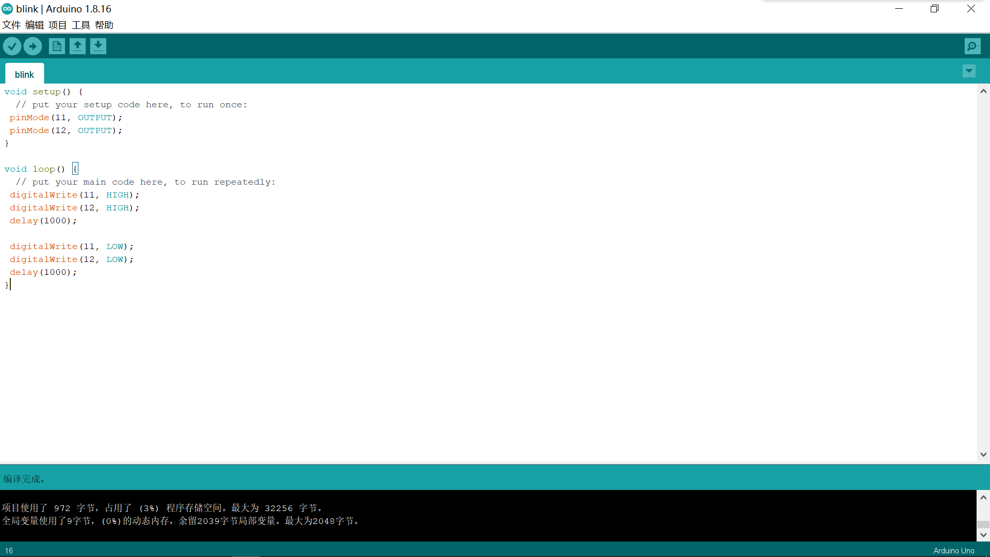

void setup() {

// put your setup code here, to run once:

pinMode(11, OUTPUT);

pinMode(12, OUTPUT);

}

void loop() {

// put your main code here, to run repeatedly:

digitalWrite(11, HIGH);

digitalWrite(12, HIGH);

delay(1000);

digitalWrite(11, LOW);

digitalWrite(12, LOW);

delay(1000);

}